

DLD Course Assignment#5

By:  
  
Name:  
Abdul-Rehman  
Roll.no:  
19l-1135  
Section:   
CS-D

**Q-1**

**(a)**

**State Table:**

**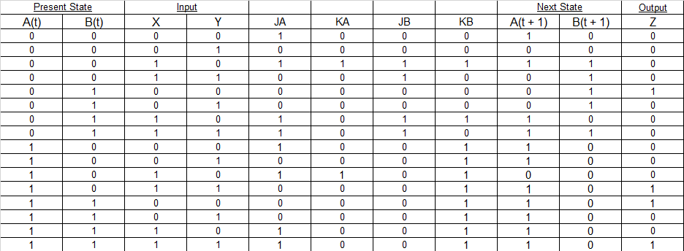   
  
a**

**(b)**

**State Diagram:**

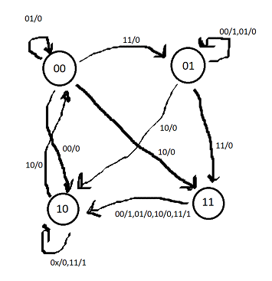

**Q-2  
(a)**

**Logic Diagram:**

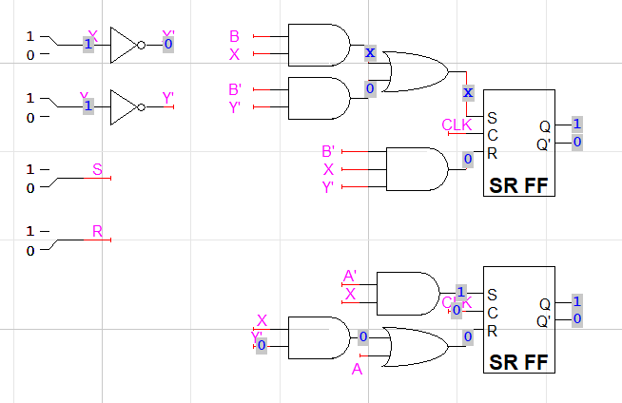

**(b)**

**State Table:**

**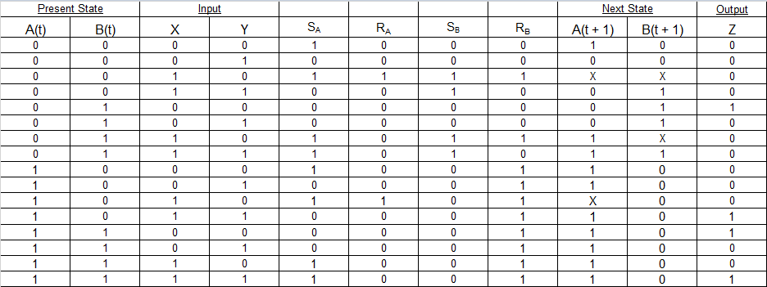   
  
  
  
  
  
  
  
  
a**

**(c)**

**State Diagram:  
  
  
  
Q-3**

**(a)**

**Input Equations:**

**D0= Cnt⊕Q0**

**D1= Cnt'.Q1+Cnt.Q0.Q1'+Cnt.Q0'.Q1**

**a**

**(b)**

**Output Equations:**

**Y= Q0.Q1**

**A  
(c)  
State Table:**

|  |  |  |  |  |  |
| --- | --- | --- | --- | --- | --- |
| Present State | | Input | Next State | | Output |
| Q0 | Q1 | Cnt | Q0+ | Q1+ | Y |
| 0 | 0 | 0 | 0 | 0 | 0 |
| 0 | 0 | 1 | 1 | 0 | 0 |
| 0 | 1 | 0 | 0 | 1 | 0 |
| 0 | 1 | 1 | 1 | 1 | 0 |
| 1 | 0 | 0 | 1 | 0 | 0 |
| 1 | 0 | 1 | 0 | 1 | 0 |
| 1 | 1 | 0 | 1 | 1 | 1 |
| 1 | 1 | 1 | 0 | 0 | 1 |

**a**

**(d)  
State Diagram:**

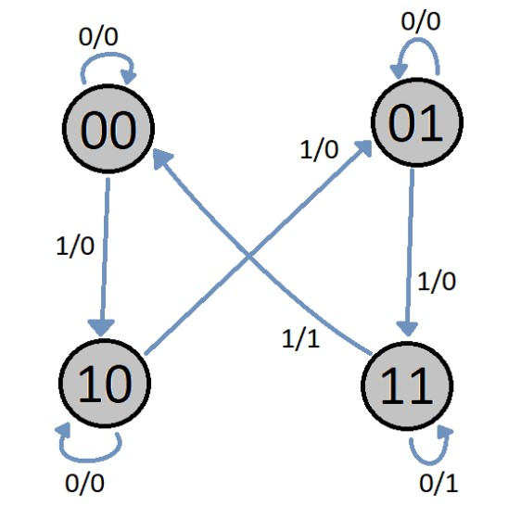

**Q-4**

**(a)**

**Logic Diagram:**

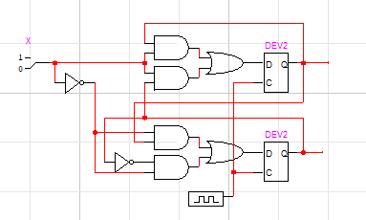

**(b)**

**State Table:**

|  |  |  |  |  |  |
| --- | --- | --- | --- | --- | --- |
| Present State | | Input | Next State | | Output |
| Q0 | Q1 | Cnt | Q0+ | Q1+ | Y |
| 0 | 0 | 0 | 0 | 0 | 0 |
| 0 | 0 | 1 | 1 | 0 | 0 |
| 0 | 1 | 0 | 0 | 1 | 0 |
| 0 | 1 | 1 | 0 | 0 | 0 |
| 1 | 0 | 0 | 1 | 0 | 0 |
| 1 | 0 | 1 | 1 | 1 | 0 |
| 1 | 1 | 0 | 1 | 1 | 0 |
| 1 | 1 | 1 | 0 | 1 | 1 |

**(c)**

**State Diagram:**

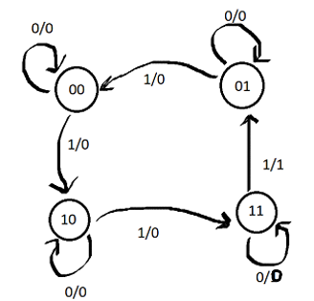

**Q-5**

**(a)**

**State Table:**

|  |  |  |  |  |  |  |
| --- | --- | --- | --- | --- | --- | --- |
| Present State | | Input | | Next State | | Output |
| A(t) | B(t) | X | Y | A(t + 1) | B(t + 1) | Z |
| 0 | 0 | 0 | 0 | 0 | 0 | 0 |
| 0 | 0 | 0 | 1 | 0 | 1 | 0 |
| 0 | 0 | 1 | 0 | 0 | 1 | 1 |
| 0 | 0 | 1 | 1 | 0 | 0 | 0 |
| 0 | 1 | 0 | 0 | 0 | 0 | 0 |
| 0 | 1 | 0 | 1 | 0 | 0 | 0 |
| 0 | 1 | 1 | 0 | 1 | 1 | 1 |
| 0 | 1 | 1 | 1 | 1 | 1 | 1 |
| 1 | 0 | 0 | 0 | 0 | 0 | 1 |
| 1 | 0 | 0 | 1 | 0 | 0 | 0 |
| 1 | 0 | 1 | 0 | 1 | 0 | 1 |
| 1 | 0 | 1 | 1 | 1 | 0 | 0 |
| 1 | 1 | 0 | 0 | 1 | 0 | 1 |
| 1 | 1 | 0 | 1 | 0 | 1 | 1 |
| 1 | 1 | 1 | 0 | 0 | 1 | 0 |
| 1 | 1 | 1 | 1 | 1 | 0 | 1 |

**(b)**

**DA = A’BX+BXY+AB’X+ABX’Y’  
DB=A’XY’+A’BX+BXY’+A’B’X’Y+ABX’Y  
Z= A’XY’+ BXY +ABX’+AX’Y’**

**(c)**

**Logic Diagram:  
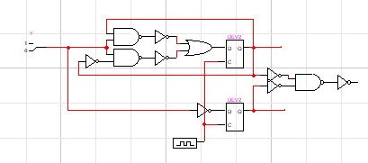**

**Q-6**

**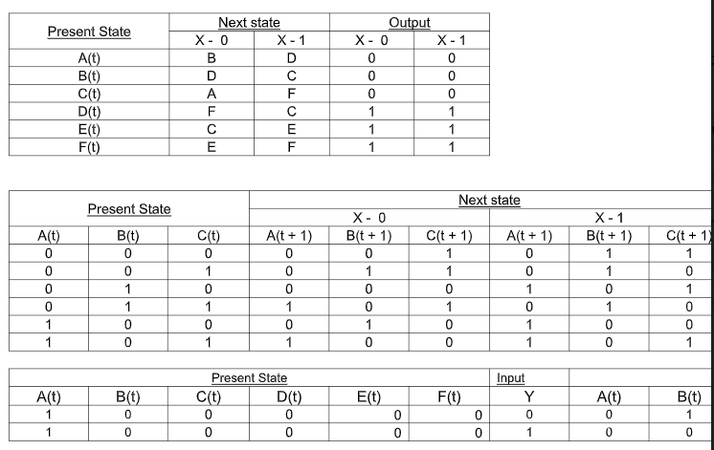  
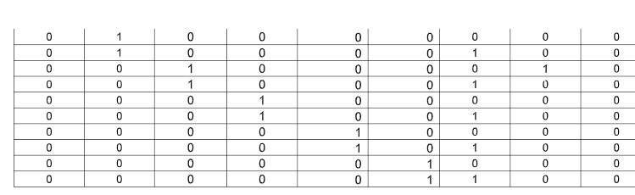**

**Q-7**

**(b)**

**J1=X’Q2  
K1=XQ2’+X’Q2  
J2=X+Q1  
K2=Q1**

**(c)**

**Z=XQ1Q2’**

**(d)**

|  |  |  |  |  |  |
| --- | --- | --- | --- | --- | --- |
| Present State | | Input | Next State | | Output |
| Q0 | Q1 | X | Q0+ | Q1+ | Z |
| 0 | 0 | 0 | 0 | 0 | 0 |
| 0 | 0 | 1 | 0 | 1 | 0 |
| 0 | 1 | 0 | 1 | 1 | 0 |
| 0 | 1 | 1 | 0 | 1 | 0 |
| 1 | 0 | 0 | 0 | 1 | 0 |
| 1 | 0 | 1 | 0 | 1 | 1 |
| 1 | 1 | 0 | 0 | 0 | 0 |
| 1 | 1 | 1 | 1 | 0 | 0 |

**(e)**

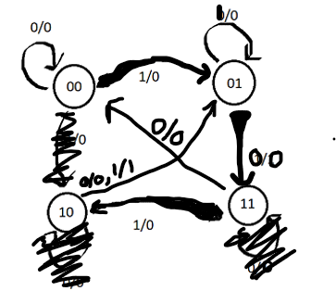

**Q-8  
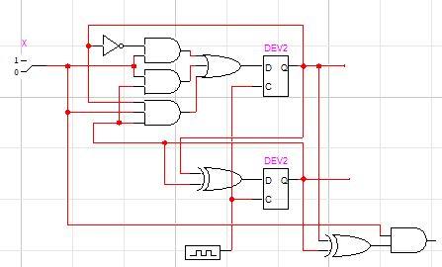**

**Q-9**

**(a)**

**Logic Diagram:**

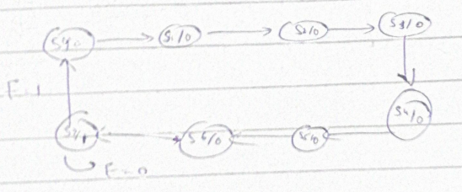

**(b)**

**State Table:  
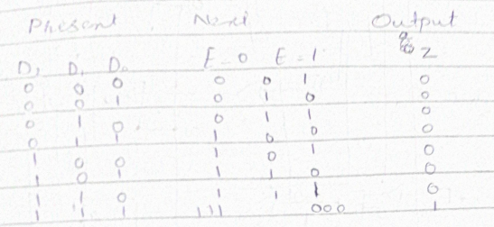**

**(c)**

**Z=D2D1D3  
D1+=D1+D0+D0D1D2E  
D2+=D1’D2+D2D3’+ D0D1D2’+D2  
D3+=D0+ D0D1D2E**

**THANK YOU**

